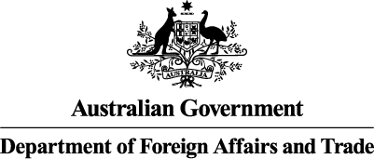
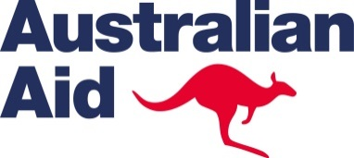
DIRECT AID PROGRAM
APPLICATION FORM
AUSTRALIAN HIGH COMMISSION
NUKU'ALOFA

Contact Details of Applicant:
Name of organisation or group:
Name of contact person:
Phone number: | Mobile number:
Email address:
Postal address:
Is your group a registered organisation? Yes No
Does your organisation have a bank account? Yes No
Description of organisation: (Please indicate the nature of the organisation that will implement the program. For example: a school, government office, religious community or NGO)

Project Details: (further details may be attached separately)
Project Name: (The name should describe what the project will achieve)

Project Description: ( Please describe what the grant will be used for)

Development outcome: (Please describe how the project will improve the lives of people in the community)

Project Finance Details:
Total amount requested in Pa’anga (up to 8000):
Sustainability and community contribution: (please describe what contribution the community will make to this program in the form of funds, labour, land, etc. and how the project will continue to provide a benefit to the community after the grant funds have been spent):

Have you applied for funding from any other source? If yes, please indicate where.

Project Assessment:
What does your project focus on? (please circle)
Poverty alleviation |  | YES | NO | Community level health/education/sanitation |  |  |  |  | YES | NO
Basic Human Rights |  | YES | NO | Essential environmental conservation |  |  |  |  | YES | NO
Rural Development |  | YES | NO | Assist disadvantaged/disabled people |  |  |  |  | YES | NO
Assist women |  | YES | NO | Purchasing computers/photocopiers/etc |  |  |  |  | YES | NO
How many people will directly benefit from the project?
MEN: | WOMEN: |  |  |  | BOYS: | GIRLS: |  | TOTAL:
Will this project involve working with children?  (A child is considered to be a person under the age of 18 years) |  |  |  |  |  |  | YES |  | NO
Projects are required to submit a full acquittal two months after completion of the project. Please indicate the expected completion date for the project and the date that the acquittal will be submitted:

Required supporting evidence attached to this application:

☐ Quotations to support you request for funds
☐ Supporting documentation? (written references from town officers, group leaders, relevant ministries or other)

Signature:___________________________ Date:_________________________

Please send this Application Form to the DAP Coordinator:
Leon Braun, Australian High Commission, (PMB 35), Nuku'alofa.
or email leon.braun@dfat.gov.au or aulola.ake@dfat.gov.au.

Note: All applications will be given careful consideration, but regretfully not all can be accepted. The Australian High Commission will respond to your request once the decision has been made.

