

Direct aid program – Tonga

Submission guidelines 2020-21

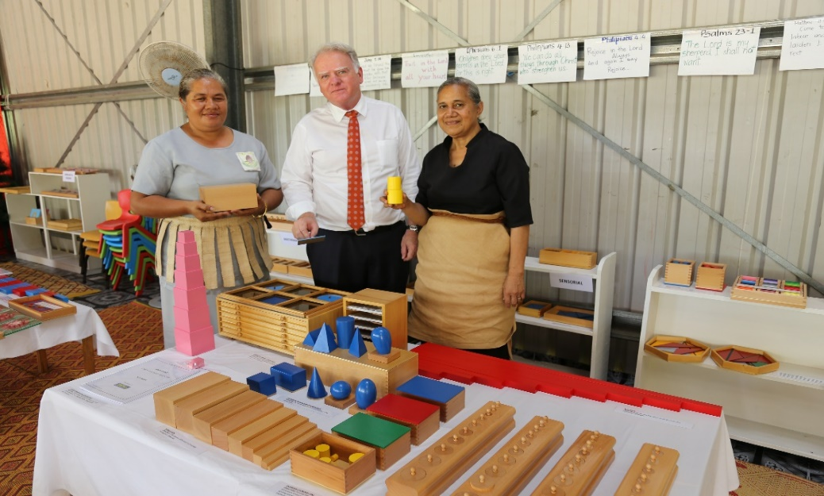  
Educational materials for pre-school children

## What is the Direct aid program (DAP)?

The Direct Aid Program (DAP) is a competitive small grants program funded by the Australian Aid program, managed by the Australian High Commission in Nuku’alofa. The DAP invites proposals **up to 8,000 pa’anga** that demonstrate a strong benefit to local communities and align with the priorities of the Australian Aid program in Tonga. These priorities include –

|  |  |
| --- | --- |
| * People with disabilities * women and girls * livelihoods * human rights | * environment and climate change * community health * arts and culture * youth and social inclusion |

The Australian High Commission may consider grants more than 8,000 pa'anga in exceptional circumstances. If you intend to submit a proposal for more than 8,000 pa'anga, you must make an appointment with the DAP coordinator to discuss. You can contact them by phone (20411) or email ([daptonga@dfat.gov.au](mailto:daptonga@dfat.gov.au))

## Key dates for DAP 2020-21

|  |  |  |  |
| --- | --- | --- | --- |
|  | **ROUND 1** | **ROUND 2** | **ROUND 3** |
| **Applications Open** | 19 October 2020 | 02 March 2021 | 03 May 2021 |
| **Applications Close** | 06 November 2020 | 25 March 2021 | 21 May 2021 |

## How to apply

To apply for a DAP Grant (8,000 pa'anga or less):

1. Click here: [Free Trial Signup — SmartyGrants](https://manage.smartygrants.com.au/signup) to register an account on the Smartygrants online system. If you can’t access the application online, you may collect a hardcopy from the Australian High Commission, Salote Road, Nuku’alofa.

2. Answer each application question according to the instructions provided. Please contact the DAP Coordinator if you have any questions about the application process.

3. Submit your application electronically to [daptonga@dfat.gov.au](mailto:daptonga@dfat.gov.au) or hard in a copy to the Australian High Commission.

#### In recent years, the DAP in Tonga has supported projects including:

* educational materials to assist students of Montessori Preschool
* papaya seeds for commercial purposes and training for farmers
* drilling of borehole for Ha’alaufuli community

#### To strengthen your application, you should consider:

* How will you maximise the number of people that will benefit from your project?
* Can the community contribute to support the project (land, material, labour or resources)?
* How can the project continue to provide a benefit to the community after the funding has been spent?

#### What types of projects are **not** eligible under the DAP?

* issuing cash grants, cash prizes, grants programs, micro-credit schemes or commercial ventures
* buying livestock, vehicles, lawnmowers, weed eaters, water tanks or fences for individual households
* improvements to an individual’s house or land
* any overseas travel
* routine, recurring running costs and administrative expenses including office rental and utility costs, spare parts, routine maintenance and reports, or staff salaries.

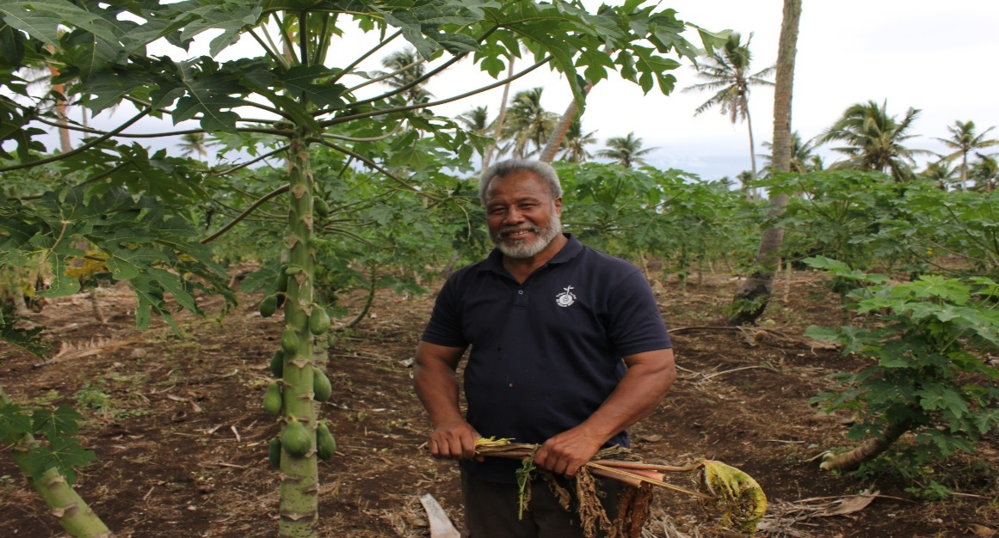  
Papaya seeds for commercial and training purpose